Non-Tenure Multiple Year Appointment Renewal/Non-Renewal

- Unit Processing
- Unit’s will receive an email from KU HRM providing information regarding the non-tenure track faculty comprehensive evaluation process. Units that have evaluations due for the upcoming period will have pre-populated forms ready for completion in their Perceptive Content workflow queue.
- After the comprehensive evaluation process within the unit has been completed, the Dean’s office or established hierarchy should follow the steps below:
  - Log into Perceptive and go to your PRV-Renewal Forms Review queue in the PRV-Faculty Events workflow to complete the forms that have been loaded.
  - Have the employee’s evaluation form readily available for reference and to attach to the Perceptive form.
  - Units will receive weekly email alerts from Perceptive to keep informed of unprocessed forms in their queue.
Current Information
Forms will be pre-populated with employee data from HR/Pay. | 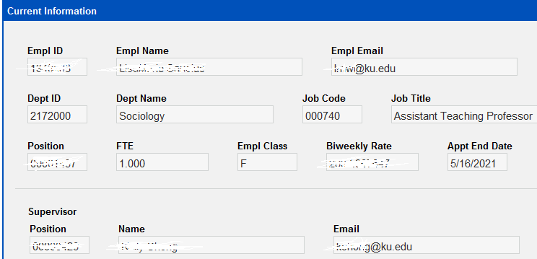

Unit Evaluation
If the Unit Recommends Reappointment  NOTE: Required fields are outlined in red. The red outline goes away when the corresponding field is entered.  - Enter Evaluation Completed date.  - After you enter a date, the rating drop-downs are activated. Enter Unit/Dept and Dean/VP/VC rating from the evaluation form.  - Unit Recommends Reappointment. Select Yes or No.  - Select Yes to recommend reappointment. Additional data entry fields will open.  - New Appt Start Date (must be after the current Appt End Date) and New Appt End Date (must be within three years of current Appt Start Date).  - Requesting Title Change. Select Yes or No.  - If you select Yes, Search for Job Title appears. Search for and select the appropriate Job Title. For example, if you enter Prof, the system will return all Job Titles that start with Prof. Refer to the form for additional documentation that must be attached.  - FTE Change? Select Yes or No. If Yes, enter New FTE.  - Biweekly Change? Select Yes or No. If Yes, enter New Biweekly rate.  - Funding Allocation if necessary. Five rows maximum. If additional rows for funding are needed, please work with your SSC HR Representative to complete a PAF.  - Add Unit Comments (optional)  - Check the box to indicate that you have attached the Comprehensive Evaluation form. Your name and date will default to the form.  - To attach the evaluation form:  - Go to the menu and select View – Thumbnails.  - Drag/drop the evaluation form to the Thumbnails section at the bottom.  - SAVE. Use the arrows at the bottom to return to the form.  - Make sure all fields outlined in red have been completed. NOTE: Because the forms are already in workflow, Perceptive cannot provide an error message if required fields are not completed.  - Route Forward. Your form will go to the Office of Faculty Affairs for final review. | 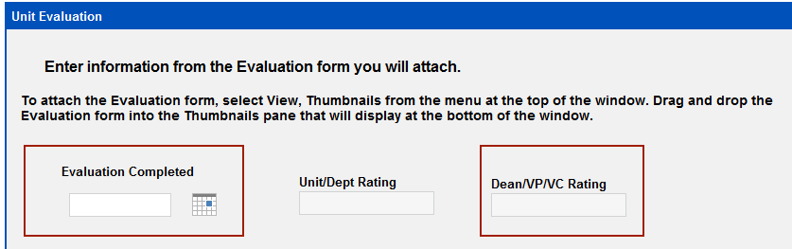  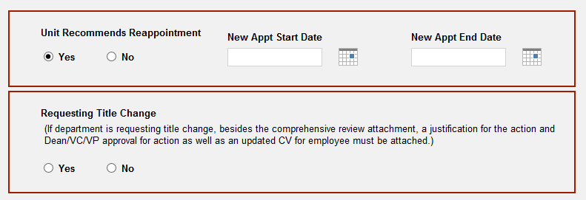  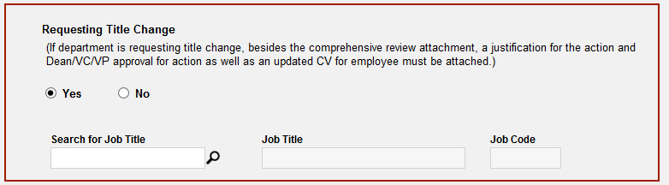  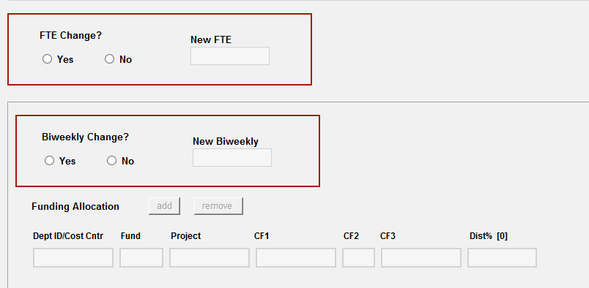  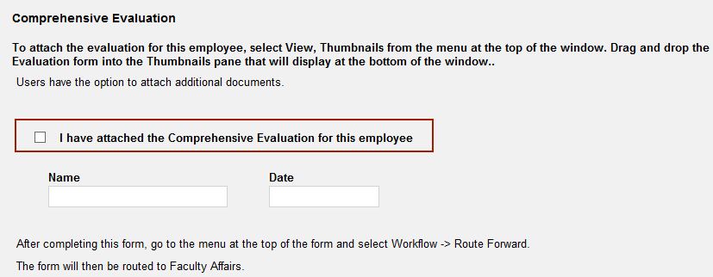
If the Unit Recommends NOT to Renew  NOTE: Required fields are outlined in red. The red outline goes away when the corresponding field is entered.  - Enter Evaluation Completed date.  - After you enter a date, the rating drop-downs are activated. Enter Unit/Dept and Dean/VP/VC rating from the evaluation form.  - Select No. No other entry is required.  - Add Unit Comments (optional).  - Check the box to indicate that you have attached the Comprehensive Evaluation form. Your name and date will default to the form.  - To attach the evaluation form:  - Go to the menu and select View – Thumbnails.  - Drag/drop the evaluation form to the Thumbnails section at the bottom.  - SAVE. Use the arrows at the bottom to return to the form.  - Make sure all fields outlined in red have been completed. NOTE: Because the forms are already in workflow, Perceptive cannot provide an error message if required fields are not completed.  - Route Forward. Your form will go to the Office of Faculty Affairs for final review. | 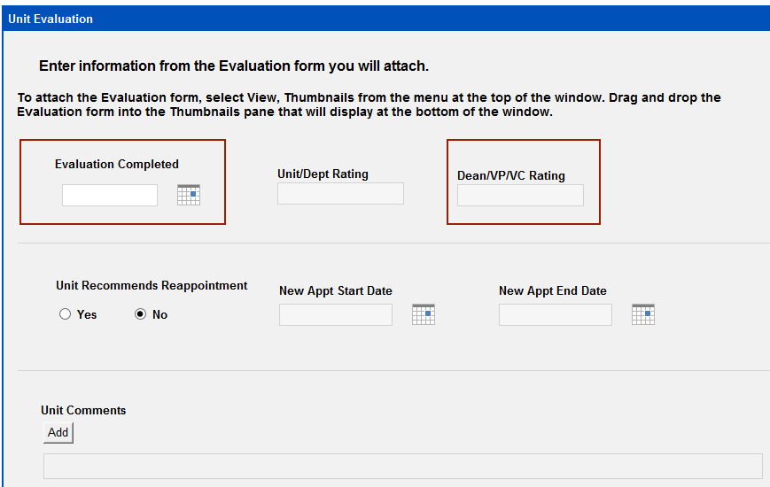

- Faculty Affairs Processing Steps:
- When the Units Route Forward, the forms will be received in the PRV – Renewal Forms Provost Rvw queue.
- If necessary, the Vice Provost for Faculty Affairs may route forms back to the Unit. Go to Workflow - Route Up and select the Unit queue.
- Faculty Affairs will receive weekly email alerts from Perceptive to keep informed of unprocessed forms in their queue.

Faculty Affairs
If the VP for Faculty Affairs Agrees with Unit Renewal Decision:  - Select Agree with Unit Renewal  - Faculty Affairs Comments (Optional. Comments will appear on the 14-day notification email.)  - Check the Unit Evaluation section to make sure all fields outlined in red have been completed. If needed, you can send the form back to the Unit by going to Workflow – Route Up and select the Unit queue. NOTE: Because the forms are already in workflow, Perceptive cannot provide an error message if required fields are not completed.  - Route Forward. The Email Notification to the Hiring Unit Process starts. | 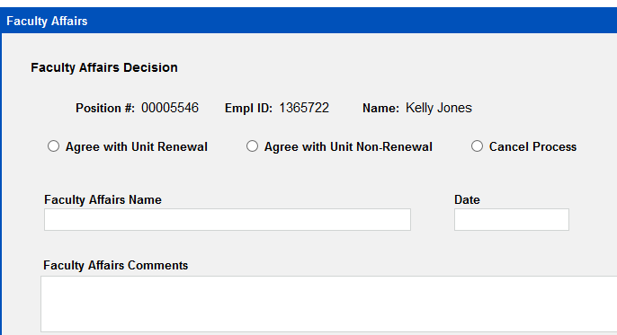
If the VP for Faculty Affairs Agrees with Unit Renewal BUT Terms Need Modification  - Select Agree with Unit Renewal.  - Select Modify Terms.  - The Unit terms will prefill. You may change any of the Terms as necessary. To use the Terms as entered by the Unit, leave them set to the prefilled data, do not change.  - If necessary, update the Mod Appt Start Date (must be after the current Appt End Date) and/or update the Mod Appt End Date (must be within three years of current Appt Start Date).  - Requesting Title Change. If necessary, change the Yes/No selection. If you select Yes, Search for Job Title appears. Search for and select the appropriate Job Title. For example, if you enter Prof, the system will return all Job Titles that start with Prof.  - FTE Change?  - If necessary, change the Yes or No selection.  - If Yes, enter or update Mod FTE. NOTE: If the Unit selected Yes for FTE Change and you select No, the FTE from the Current Information section will be used in the renewal notification to the employee. Selecting No will clear the Mod FTE field. Re-selecting Yes will NOT reload the Unit FTE prefill.  - Biweekly Change?  - If necessary, change the Yes or No selection.  - If Yes, enter or update Mod Biweekly. NOTE: If the Unit selected Yes for Biweekly Change and you select No, the Biweekly Rate from the Current Information section of the form will be used in the renewal notification to the employee. Selecting No will clear the Mod Biweekly field. Re-selecting Yes will NOT reload the Unit Biweekly prefill.  - Funding Allocation  - If necessary, enter or update a maximum of five rows.  - Faculty Affairs Comments (Optional. Comments will appear on 14-day notification email.)  - Route Forward. The Email Notification to the Hiring Unit Process starts. | 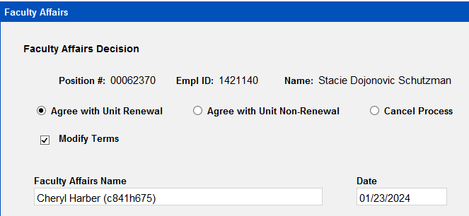  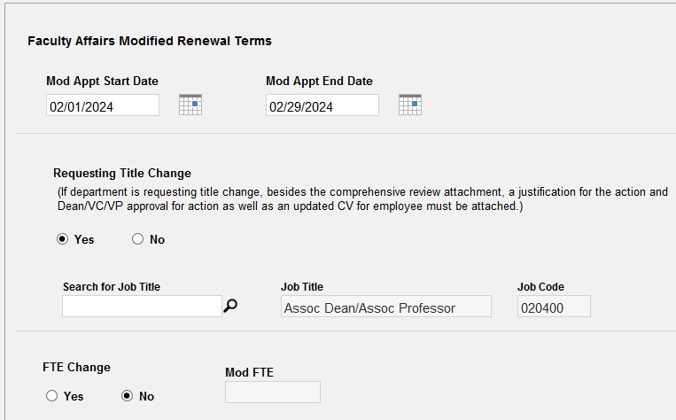  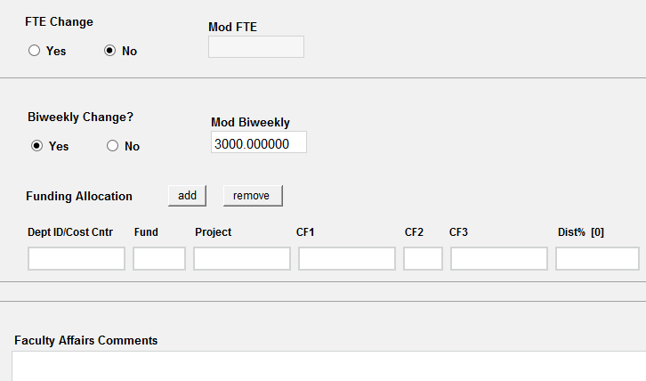
If the VP for Faculty Affairs Agrees with Unit Non-Renewal:
- Select Agree with Unit Non-Renewal.
- Faculty Affairs Comments (Optional. Comments will appear on 14-day notification email.)
- Route Forward. The Email Notification to the Hiring Unit Process starts.
If the VP for Faculty Affairs Wants to Cancel Process:
- Select Cancel Process. The Office of Faculty Affairs ends the process. Discussion with Unit, etc., is handled separately.
- No emails are automatically sent.
- Route Forward. Form goes directly to the Employee folder.
- Process ends, no further workflow.

- Email Notification to the Hiring Unit Process – 14-Day Communication Period
- Perceptive Content will send a notification email to the individuals below once a determination is made by the VP for Faculty Affairs and the form as been routed forward. This notification provides the Dean’s and/or Supervisor advanced notification of the evaluation renewal outcome so that a verbal conversation can occur with the employee prior to the automatic distribution of the official notification letter.
  - Unit Person Working the Queue
  - Supervisor
  - Dean
- After 14-days Perceptive Content automatically sends the Final Appointment Renewal or Non-Renewal Notification to the employee.

- Final Appointment Renewal or Non-Renewal Notification E-Mail
- After 14-days, Perceptive Content automatically sends the final Renewal or Non-Renewal notification email to the following:
  - Employee
  - Unit Person Working the Queue
  - Supervisor
  - Dean
- The final renewal or non-renewal email is attached to the form and routed to the SSC and HR Appointment queues for processing.

- HR Appointment Processing - Renewal

- Perceptive Content sends daily email alarms when forms are in the PRV-Faculty Events HR queue.
- HR Appointment enters renewal changes to HR/Pay.
- Route Forward to send the form, related notification email and evaluation to the Employee folder.
- Process ends.

- SSC and HR Appointment Processing – Non-Renewal

- SSC Processing:
  - Perceptive Content sends daily email alerts when forms are in the PRV-Faculty Events SSC queue.
  - Prepare ePAF for supervisor changes if needed. Submit to send the ePAF through existing workflow to HR Appointment.
  - Route Forward to send the form, related notification email and evaluation to PRV-Faculty Events HR queue for termination entry to HR/Pay.

- HR Appointment Processing:
  - Enter termination and supervisor changes to HR/Pay
  - Route Forward to send the ePAF, form, related notification email and evaluation to the Employee folder.
  - Process ends.

