Promotion and Tenure Candidate Verification Form and List of Supporting Materials

Candidate

Candidate:
 |  | Last Name |  | First Name |  | Middle Initial

Candidate’s Verification

I have provided on the promotion and tenure forms the information I consider appropriate to document my record for promotion and/or tenure. In addition, I have supplied for inclusion in my promotion and/or tenure file all materials that I consider appropriate to document the information on the forms. I have reviewed the factual information I have provided, and I am satisfied with its completeness and accuracy. I understand that additional materials will be added to the file during the review process.
Candidate’s Signature: |  |  | Date:

List of Supporting Materials
Provide a list of the contents of the Supporting Materials folders, both required and optional. Supporting Materials may be submitted in paper copy, electronically, or a combination of the two. Please do not duplicate documents in paper and electronic copy.
- Electronic submission is required only for the summary of the numerical student evaluation reports.
- Student comments are required only if they are used in the annual evaluation.
- Supporting materials submitted as paper copies should be placed in letter-size file folders labeled appropriately. CDs or DVDs of artistic work may also be submitted in the Supporting materials box.
  - Materials may be placed in binders to facilitate handling. All folders and materials should be clearly labeled.
- Although the promotion and tenure dossier should be complete, it should not contain extraneous material such as works in which the candidate’s name is merely mentioned.
Note: The FSRR Article VI specifically prohibits the inclusion of the progress toward tenure review evaluation by either the candidate or the unit.
Save this page with your signature and the list of supporting materials in a pdf file for submission to the initial level review as Lastname, FirstInitial Candidate Verification.pdf.
Delete the instructions on page two and keep a copy of page three for your records. Pages four and five contain examples of the suggested electronic folder layout and filenames.

Supporting Materials Instruction
Required Materials
- All numeric student evaluation summary forms for courses listed on the P&T CV. The absence of student numeric evaluations for specific courses must be justified. Under Regents’ and university policy, quantitative student evaluations are required.
  - Place the student evaluation summary reports in reverse chronological order (most recent semester first) and save them in one pdf file named Lastname, FirstInitial Student Eval Summaries.pdf in the folder Supporting Materials/Required/Student Eval Summaries.
- All original student evaluation forms with comments IF student comments are part of the review in the department or school/college.
  - Scanned comment forms may be submitted for each course on the P&T CV with the filename Lastname, FirstInitial Student Comments Course.pdf. These files should be saved in the Supporting Materials/Required/Student Eval Summaries folder.
  - If student comments are not required for review at the department or school/college level, candidates may choose to submit them following the procedure above. All comments from all courses must be included.
- One copy of all published or completed work since last promotion or since KU appointment (as appropriate).
        - If pre-KU works are considered by outside reviewers, one copy of each of those works should also be included.
        - Electronic copies of publications (journal articles, book reviews, book chapters, etc.) in PDF format are required, but authored or edited books may be submitted in hard copy if electronic copies are not available.
        - Create one electronic file per publication, appropriately named, with file names limited to a maximum of twenty-five characters.
        - Provide full bibliographic information for the work within each electronic file.
        - Do not submit works in which your scholarship or creative activity is merely cited. Large portfolios of artwork and music scores may be submitted where necessary, though CDs or DVDs of such work are preferred. Works submitted electronically may be grouped by folder name. Please see example on page four. Please do not duplicate documents in hard and electronic copy.
Optional Materials
These are the types of optional materials that may be included in the dossier. Electronic files are preferred. Paper copy documents will be accepted. Please do not submit documents in both electronic and paper copy. Use the guide on page four to organize your electronic folders. Please be sure not to exceed twenty-five characters per file name.

- Additional documentation of teaching effectiveness. Examples include a comprehensive teaching portfolio, course syllabi, reflective journals, sample assignments, efforts to improve teaching through reflective journals, course design changes to enhance student learning, descriptions of how publications or research activities relate to teaching, unsolicited letters from students, etc.
- Additional documentation of scholarly or creative accomplishments. Examples include funded external grant applications or those in submission, published reviews of the scholarly or creative work, articles or news coverage of the work, etc.
- Additional documentation of service accomplishments.

Candidate Dossier Checklist
Check that all materials below are included in the dossier. Keep a copy of this document for your records. It is not necessary to forward this document to the initial level review.
Candidate Documents
☐ Last Name, First Initial P&T CV.pdf
- Candidate P&T Curriculum Vitae (one pdf file)
☐ Last Name, First Initial Candidate Statement.pdf
- Candidate Statements on Teaching, Professional Performance, Research/Scholarship/Creative Activity, and Service as appropriate to your position/s (one pdf file)
☐ Last Name, First Initial Candidate Verification.pdf
- Candidate Verification Form, signed and dated, and List of Supporting Materials (one pdf file)
Required Supporting Materials

☐ Student Evaluation Summaries.pdf
- A file containing all summary student evaluation reports (in reverse chronological order) for courses listed on CV (if applicable) The summary student evaluation reports must be included in an electronic file named Last Name, First Initial Student Eval Summaries.pdf.
- If your department or school also uses student comments in assessing teaching, the evaluation forms with comments must also be submitted for each class.
☐ Published or Completed Work Since Appointment at KU or Since Last Promotion
- One copy of each published or completed work since appointment at KU or since last promotion, as appropriate (as listed on CV). With the exception of authored or edited books and works of art, these should be submitted in electronic formats or media.

Sample Layouts

Sample Layout of Required Candidate Documents

Sample Filenames for Electronic Submission of Required Supporting Files
(It is not required that you use these filenames. If you do not use the suggested filenames, please be sure not to exceed twenty-five characters for the filename.)

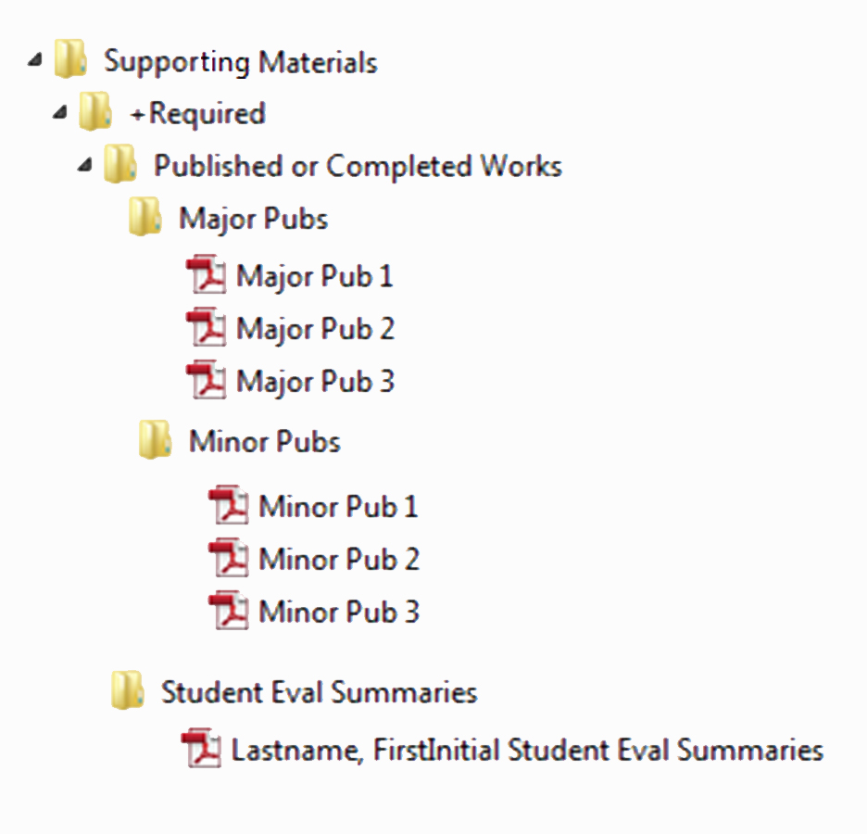
Sample Filenames for Electronic Submission of Optional Files (It is not required that you use these filenames. If you do not use the suggested filenames, please be sure not to exceed twenty-five characters for the filename.)

Optional files, such as syllabi and student comments (when not required) may be named using the course number:

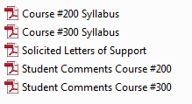

Presentations, grants, and patent filenames may use the same numbering system as the CV, for example:
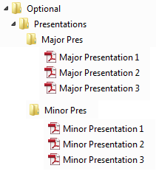
Complete Sample Folder Layout for Electronic Submission of Files
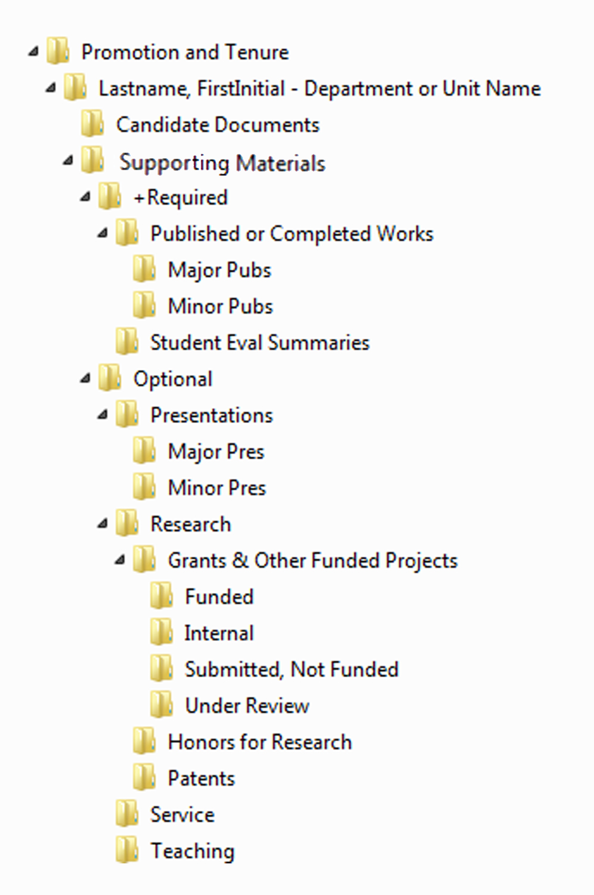

Questions

Contact the Office of Faculty Affairs at facultyaffairs@ku.edu

